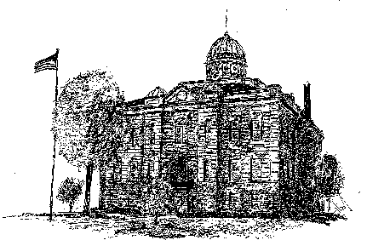
MENARD COUNTY ASSESSMENT OFFICE
102 S 7TH ST, PETERSBURG, IL 62675
217-632-4461
www.menardcountyil.com

APPLICATION FOR GENERAL HOMESTEAD EXEMPTION
SUBJECT TO A LEASE AGREEMENT
35 ILCS 200/15-175 AS AMENDED BY PUBLIC ACT 97-1125

Exemption Amount. Under 35 ILCS 200/15-175, qualified taxpayers are permitted an exemption that will remove up to $6,000 from the equalized assessed value before taxes are calculated.
Application. After initial approval, the exemptions will be renewed automatically. If the property is no longer eligible for the exemption, it is the responsibility of the taxpayer to remove the exemption to avoid possible interest and penalties.
YES / NO I occupy the property identified below as my principal residence. A copy of my current photo ID (driver’s license or state issued photo ID) is attached.
YES / NO I am responsible for the payment of real estate taxes on this property. A copy of the signed lease that
states the lessee is liable for the payment of property taxes is attached.

YES / NO I also affirm that the structure in which I reside is NOT a mobile home on which I pay mobile home tax, and that it is a single family dwelling as defined in the current Zoning Ordinance of Menard County. The Menard County Zoning Ordinance can be viewed at www.menardcountyil.com/departments/zoning-gis/

Address of Property:
Address: ______________________________________________________
(City / State) ___________________________________________________
I have occupied this property since ___________________________________________.
Do you own any other real estate anywhere in the United States?
- Yes; the address of the real estate is.
- No; this is the only property I/we own.

I hereby affirm that I do not receive any homestead exemption on any other property in Illinois or any other state. If I do address of the property is: ______________________________________

Signature of Owner of Record: __________________________________________
Print Name: __________________________________________________________

Signature (s) of Taxpayer/Lessee: _________________________________________
Print Name (s):________________________________________________________
Date _______________________________________________________________

